 Apply for the Marge Gruenes Scholarship

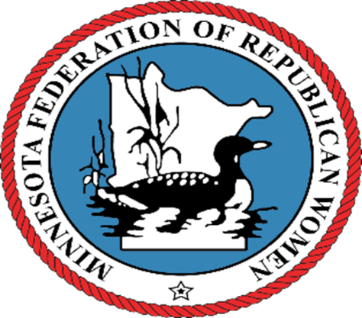

Calling all sophmore, junior or senior college women.

(Must have completed first year of college and be classified at least a sophmore.)

A **$1000** scholarship will be awarded by the

MN Federation of Republican Women

to a qualified young lady.

**Children, grandchildren or friends of members of Republican Women Clubs may apply. If you know of a qualified young lady please ask her to complete the application and return to Elaine Loesch by August 31st, 2024. The scholarship will be awarded at the meeting of geographically appropriate club. Application can be found at** [**www.MNFRW.**](http://WWW.MNFRW.COM)**com or contact Elaine Loesch at**

**651-260-8005 or** eloesch@charter.net