Apply for the Marge Gruenes Scholarship
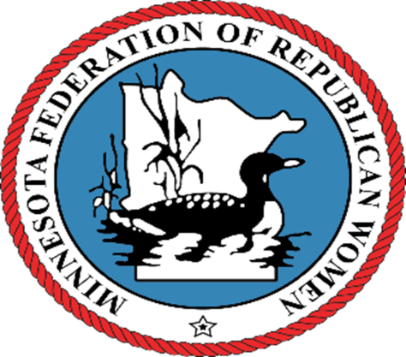
Calling all sophOmore, junior or senior college women.
(Must have completed first year of college and be classified at least a sophomore.)
A $1,000 scholarship will be awarded by the
MN Federation of Republican Women
to a qualified young lady.

Children, grandchildren or friends of members of Republican Women Clubs may apply. If you know of a qualified young lady please ask her to complete the application and return to Elaine Loesch by July 1, 2022. The scholarship will be awarded at the August meeting of geographically appropriate club. Application can be found at www.MNFRW.com or contact Elaine Loesch at
651-423-0556 or eloesch@charter.net

