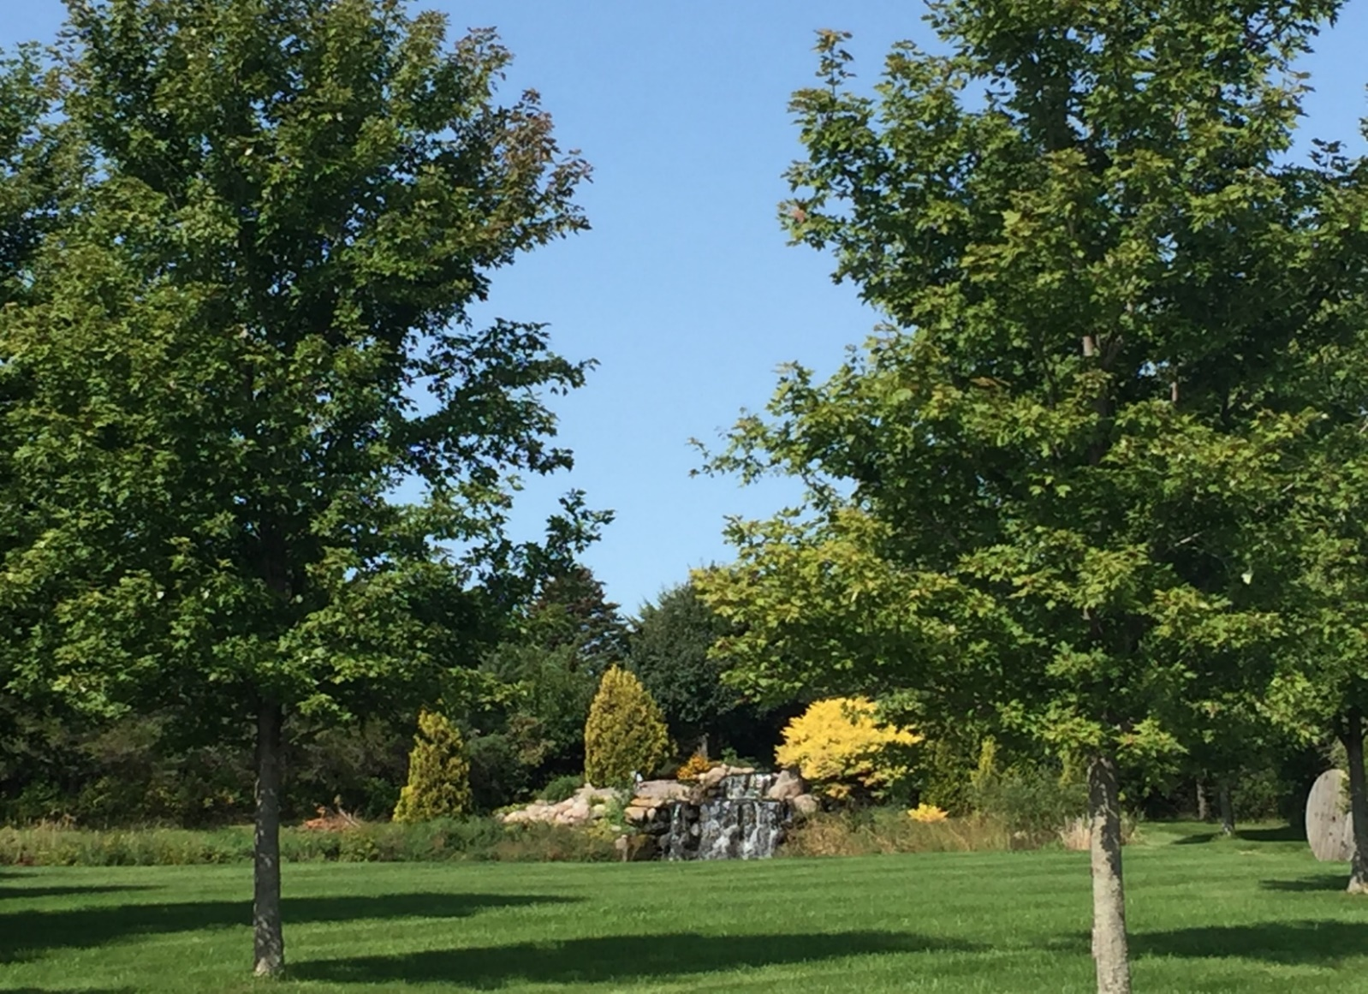WHEN: Tuesday September 28, 2021 5:00 p.m. – 7:00 p.m.
Have fun with other like-minded people!
Networking – Education on Republican Issues – Be empowered in the political process
Prairie Winds Republican’s Women’s Club
Monthly Meeting

WHERE: Suzanne Murphy Residence, 26605 Sundberg Ave, Worthington MN 56187
RSVP: JoAnne Smith at jmsmith@swwnet.com OR 507-360-0755
Please bring your own beverage and chair, sandwiches will be available
Agenda:
- Welcome, prayer, Pledge of Allegiance, introductions
- Suzanne Murphy presentation
- Call meeting to order:
- Present agenda – approve
- Treasures report – approve
- Secretary’s report – approve
- Old Business
- Kendall and Sheila Qualls gave an excellent CRT presentation at our August meeting. 45 people attended, including the publisher and editor of the Fulda Free Press. Visit TakeChargeMN.com for more information.
- Other old business
- New Business:
- Information on Congressional District Director position
- Business cards to get our message out? Discussion
- Kim Crockett will be the speaker in October at the Library in Jackson regarding Election Integrity Training
- Action Items – Bethani Fellows presentation
- State Convention – Delegates, alternates – anyone is welcome to attend
- Any other new business
- Adjourn

